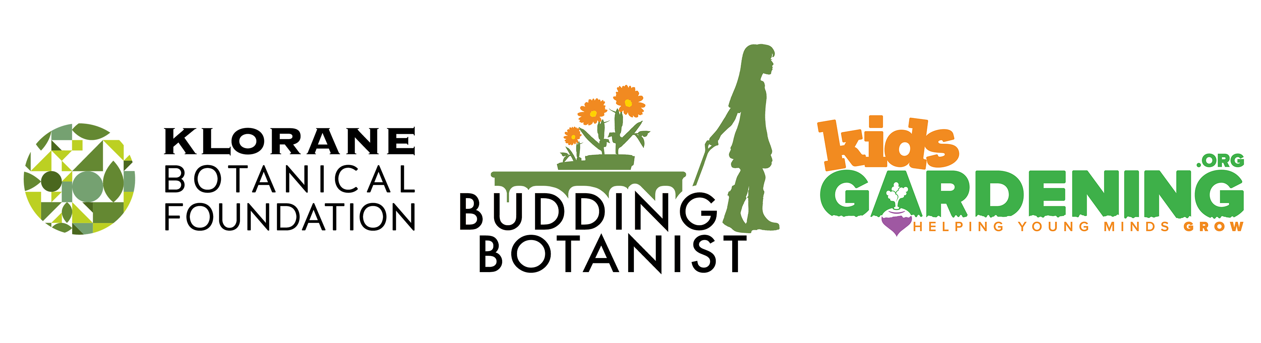
KidsGardening is proud to be partnering with the Klorane Botanical Foundation to offer the 2019 Budding Botanist Grant.
The Klorane Botanical Foundation is committed to supporting programs to teach respect for the environment and protect nature through the preservation of plant species and biodiversity. Designed to further their mission, The Budding Botanist Grant will help our youngest citizens learn about plants, explore their world and inspire them to take care of the life they discover in their local ecosystems.
Who is Eligible to Apply: Any Title I public or charter school in the United States is eligible to apply. Applicants must be planning a new or expanding an existing school garden program designed to teach students about environmental sustainability and the importance of biodiversity.
Grant Recipient Requirements: Information about the garden programs of grant recipients will be shared through images and videos digitally and through social media. Grant winners must be willing to host a garden celebration planned with the help of KidsGardening and the Klorane Botanical Foundation between March and June of 2019. Winners must be open to hosting guests from local media outlets at these events. They must also distribute and collect media release forms for all participating students and teachers. All funded gardens must be able to be installed by the end of the 2018-2019 school year. Grant recipients will also be required to complete an end of the year report by December 2019.
Due Date: Applications must be submitted by November 19, 2018.
The following questions are included in the KidsGardening 2019 Budding Botanist application. We strongly advise saving the questions into a Word document and copying and pasting your answers into the application.

Contact Information

1. Primary Contact:

2. Primary Contact Title:

3. School/Organization:

4. Email Address:

5. Phone:

6. Garden Program Name:

7. Shipping Address (street address, no P.O boxes please):
Please provide one physical address. Award package will ship to this address.

8. City:

9. State:

10. Zip Code:

11. Daytime Phone Number:
Please list a phone number that corresponds with the shipping address.

12. Organization type:
Public School
Charter School
Other:

13. What percentage of direct participants are eligible for free/reduced cost lunch programs? (*must be greater than 40%)

14. How many youth from each age group will participate directly in the garden program?
Elementary (Grades K-5)
Middle School/Junior High (Grades 6-8)
High School (Grades 9-12)

15. Is your garden already established or are you just getting started?
New/Start-up Garden
Established Garden

16. How many hours per week on average will participating youth be involved in gardening activities?

17. How many months of the year will you be gardening?

18. If chosen as a winner for the 2019 Budding Botanist Grant Program, I agree to work with KidsGardening and the Klorane Botanical Foundation to host an award ceremony between March and June 2019.
Yes
No

19. If chosen as a winner for the 2019 Budding Botanist Grant Program, our school is willing to have our story shared digitally and in social media through images and video.
Yes
No

20. If chosen as a winner for the 2019 Budding Botanist Grant Program, I agree to complete a year-end report survey including a program summary and at least 10 photos from our garden program.
Yes
No

Program Overview

21. Provide a concise overview of your garden program. List the educational goals of your program, describe the youth who will participate and how they will be engaged in the garden, and share innovative aspects of your program. If you are proposing a new school garden program, detail the planning that has been done to date toward implementing your program. If you have an established garden program, please describe the benefits children have derived from their experiences. If you are a new program, please describe the benefits you hope to achieve. (limit 1000 words)

22. Describe when and how frequently students visit your garden. How does your garden program fit into your school’s curriculum? (limit 250 words)

23. How is your garden program going to be used to promote environmental sustainability and biodiversity? (limit 500 words)

24. Will your students share what they are learning with the larger community? If so, please explain. (limit 500 words)

Volunteers and Leadership Team

25. List the individuals on your program’s leadership team and describe each leader’s experience in gardening with kids and how they are involved in your program. Also, describe how your garden program recruits and utilizes volunteer help. (Limit 500 words)

Garden Plans

26. What type of garden beds do you have or plan to install:
in ground
raised beds
containers
indoor grow lights
other

27. Briefly describe the design, or planned design, of the garden that is established or that you intend to create. Include the size of the garden and the work that has been done to date to implement your plans. (limit 250 words)

28. Describe the type of plants grown and how your choices relate to teaching students about environmental sustainability and/or biodiversity. (limit 250 words)

29. Budget. Please provide a detailed account of how you will spend the money if you are awarded a Budding Botanist Grant. If you will need additional funding, please describe how you plan to obtain it. (limit 250 words)

30. How do you plan to sustain your program in the future (e.g., ensure ongoing maintenance and leadership; build partnerships; find sources and/or funds for plant materials, services, tools, etc.)? If your program takes a break during summer months, what do you plan to do with your garden? (limit 250 words)

Attachments

Supporting Photos
31. Please attach at least 2 photos to help us better understand your program, participants, and garden site.

Garden Map
32. Please attach a scanned map of your garden site or proposed garden site that includes location and dimensions of gardens and/or raised beds.

33. Letter of Support (optional but highly encouraged)
Please attach a letter of support for your program written by someone other than the main contact. This letter can be written by an administrator, parent or community volunteer demonstrating their support of and appreciation for your program.

