2019 Youth Garden Grant Application Questions
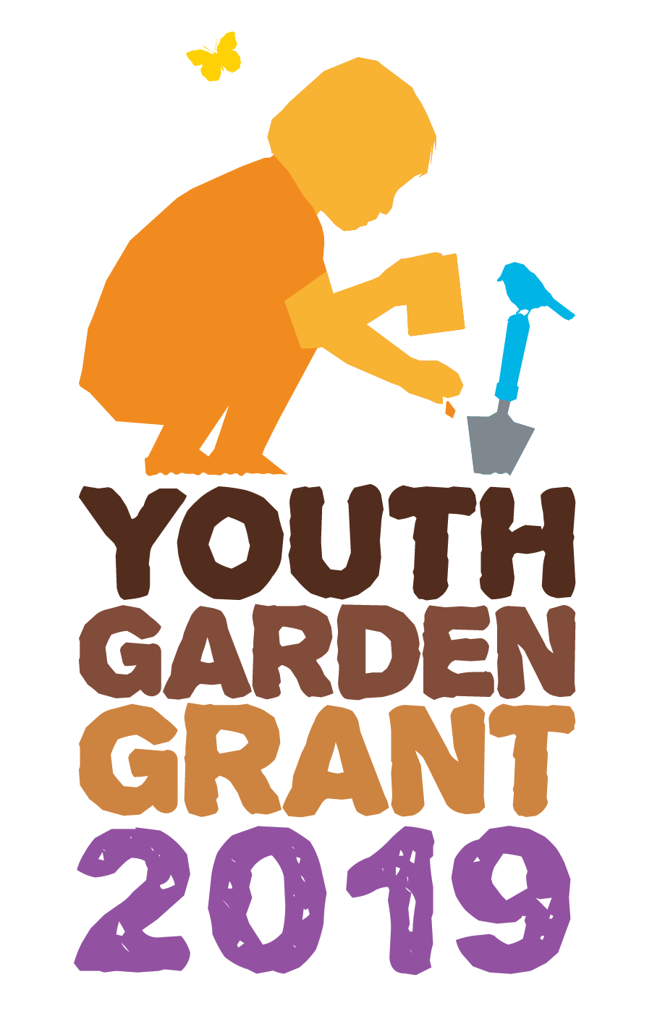

The 2019 Youth Garden Grant is an award designed to support school and youth educational garden projects that enhance the quality of life for students and their communities. Any nonprofit organization, public or private school, or youth program in the United States or US Territories planning a new garden program or expanding an established one that serves at least 15 youth between the ages of 3 and 18 is eligible to apply. The selection of winners is based on demonstrated program impact and sustainability. Previous Youth Garden Grant winners who wish to reapply must wait one year after receiving the award and must prove that their garden programs have been significantly expanded.

The 2019 Youth Garden Grant is sponsored by KidsGardening’s generous donor base including our 2019 Trellis Sponsor Gardener's Supply Company. The grant award packages also include product contributions from leading companies in the horticulture industry, including Dramm Corporation, Eartheasy, Deerbusters, Fiskars Brands Inc., Gardener’s Supply Company, High Mowing Organic Seeds, JavaCycle, SmartPots, and SunGro. A total of 25 programs will receive an award package of gardening supplies valued at $400 along with a $100 Gardener's Supply Company gift card. Additionally, the top 5 programs will receive a pallet of raised bed soil mix from SunGro and a $1000 cash prize.

Applications are due Monday, December 17, 2018. Winners will be announced and notified on Thursday, January 31, 2019. Award packages will be mailed in February 2019.

All winners are required to complete an end of the year survey, providing a minimum of 5-10 digital images of the garden program and parental release forms along with an updated program summary within six months of the award date. We will request that all year end surveys include photos of recipients using the products from the YGG award package.

Please read through the entire application before you begin. This will help you avoid duplicating information and allow you to make the best use of the available space. We strongly advise saving the questions into a Word document and copying and pasting your answers into the application. The online application system will time out after two hours, but it may time out sooner than that due to the security settings of your browser. You can save your application by clicking the "resume later" button at the top of the screen and creating a user name and password. If you have selected the "resume later" button, you will receive an email with this information along with a link that will allow you to return to your application. Make sure to save this email as you will need this information to resume. Do not select "Exit and Clear Survey" at any time or your saved application will be deleted.

Once you select “submit” you will not be able to edit or access your application. If you submit more than one application, the application submitted last will be evaluated. You will receive an online confirmation statement that the application was successfully received after you select submit. Applications that are started, but not submitted, will not be considered for the award.

1. Primary Contact:

2. Primary Contact Title:

3. School/Organization Name:

4. Email Address:

5. Phone:

6. Garden Program Name:

7. Location Name (Location of the garden by the official name of school or facility to receive the award (e.g. "Washington Elementary School," "Fairview Botanical Garden"):

8. Shipping Address (no P.O. boxes please):

9. City:

10. State or Territory:

11. Zip code

12. Daytime Phone Number:

13. Has the program received a Youth Garden Grant before?

14. If you are a previous YGG winner, what year did you receive your award?

15. Which of the following best describes your organization:
Public School
Private School
Charter School
Nonprofit Agency
Community Garden
Garden Club
Summer Camp
YMCA
Boys and Girls Club
Boy Scouts or Girl Scouts
Other:_________________

16. How many youth from each age group will participate directly in the garden program?
Ages 2-5 (preschool to k)
Ages 6-8 (grades 1-3)
Ages 9-11 (grades 4-6)
Ages 12-13 (grades 7-8)
Ages 14-18 (grades 9-12)

17. What percentage of direct participants are eligible for free/reduced cost lunch programs?

18. How many hours per week on average will participating youth be involved in gardening activities?

19. How many months of the year will you be gardening?

20. If chosen as a winner for the 2017 Youth Garden Grant, will you agree to submit a year end report with a project summary, pictures and parental photo release forms?

21. Is your garden already established or are you just getting started?
New/Start-up Garden
Established Garden

22. Program Overview: Provide a concise overview of your garden program. List the goals of your program, describe the youth who will participate and how they will be engaged in the garden, and share innovative aspects of your program. If you are proposing a new garden program, detail the planning that has been done to date toward implementing your program and if a school, how you plan to integrate the garden into your curriculum. If you have an established garden program, please describe the benefits children have derived from their experiences. If you are a new program, please describe the benefits you hope to achieve. (limit 400 words)

23. Leadership: List the individuals on your program’s leadership team and describe each leader’s experience in gardening with kids and how they are involved in your program. (Limit 250 words)

24. Garden Description. Describe the design, or planned design, of the garden that is established or that you intend to create. Include the size of the garden and the work that has been done to date to implement your plans. (limit 250 words)

25. How will the materials offered by the Youth Garden Grant complement your garden? (Limit 250 words)

26. List community members, organizations, and businesses that actively support your garden program and explain how they contribute to your garden efforts (limit 250 words).

27. Sustainability: How do you plan to sustain your program in the future (e.g., ensure ongoing maintenance and leadership; build partnerships; find sources and/or funds for plant materials, services, tools, etc.)? If your program takes a break during summer months, what do you plan to do with your garden? (limit 250 words)

28. Supporting Photos: Please attach at least 2 photos to help us better understand your program, participants, and garden site. There is a 1024KB limit on each photo file. Photos should be uploaded here in .jpg, .pdf or .png format.

29. Please attach a scanned map of your garden site that includes: 1) location and dimensions of gardens and/or raised beds, and 2) location of walkways, roads, buildings, garden structures, and natural features. There is a 1024KB limit on each photo file. Photos should be uploaded here in .jpg, .pdf or .png format.

30. Optional Letter of Support: Please attach a one page letter of support for your program written by someone other than the main contact. This letter can be written by an administrator, parent or community volunteer demonstrating their support of and appreciation for your program. There is a 1024KB limit on each photo file. Photos should be uploaded here in .jpg, .pdf or .png format.

