2021 Youth Garden Grant Application Questions
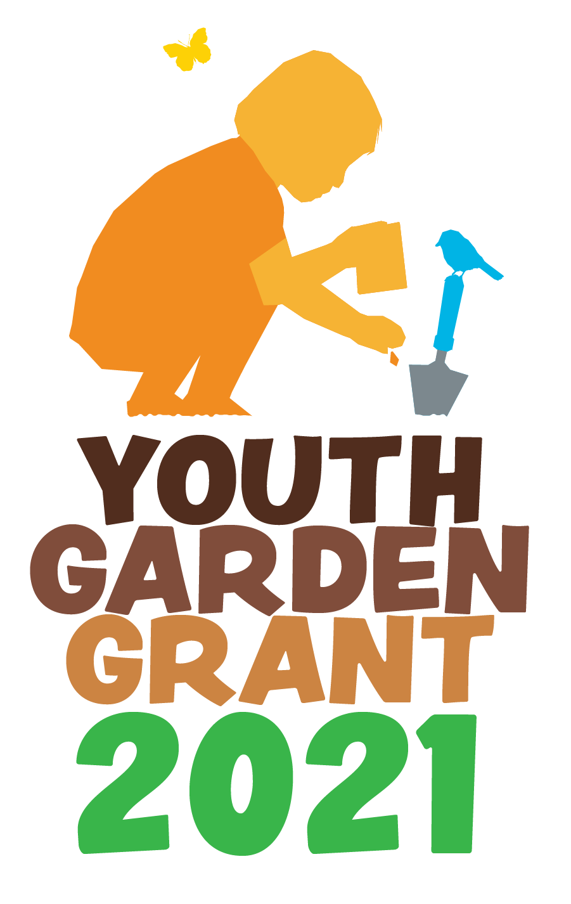
The 2021 Youth Garden Grant is an award designed to
support school and youth educational garden projects that
enhance the quality of life for students and their communities. Any nonprofit organization, public or private school, or youth program in the United States or US Territories planning a new garden program or expanding an established one that serves
at least 15 youth between the ages of 3 and 18 is eligible to apply. The selection of winners is based on demonstrated need, program impact, and sustainability. Preference will be given to programs supporting under-resourced communities. Previous Youth Garden Grant winners who wish to reapply must wait one year after receiving the award and must prove that their garden programs have been significantly expanded.
The 2021 Youth Garden Grant is sponsored by
KidsGardening’s generous donor base including our Trellis sponsor Bluestone Perennials, Blossom sponsor Corona Tools, and our various Seed Money sponsors: B.B. Barns, Botanical Interests, Epicor, Fine Gardening, Meadows Farms, and White Flower Farm. The grant award packages also include product contributions from leading companies in the horticulture industry, including Corona Tools, Dramm Corporation, GardenFreak , Gardener’s Supply Company, High Mowing Organic Seeds, JavaCycle, SmartPots, and Watex.

A total of 30 programs will receive awards. Twenty five programs will receive an award package of gardening supplies including a hand tool package, spray nozzle, a tubtrug, a paper pot press, gardening gloves, seed package, a big bag bed, a countertop gardening system, organic fertilizer, and KidsGardening curriculum books along with a $250 cash prize. The top 5 programs will receive all the items listed above, as well as a twin shut-off valve from Dramm Corporation and a $1,000 customizable garden tool package from Corona Tools.
Applications are due Friday, December 18, 2020. Winners will be announced and notified on Friday, January 29, 2021. Award packages will be mailed in February 2021.
All winners are required to complete an end of the year survey, providing a minimum of 5-10 digital images of the garden program and parental release forms along with an updated program summary within six months of the award date. We will request that all year end surveys include photos of recipients using the products from the YGG award package.
Please read through the entire application before you begin. This will help you avoid duplicating information and allow you to make the best use of the available space. We strongly advise saving the questions into a Word document and copying and pasting your answers into the application. The online application system will time out after two hours, but it may time out sooner than that due to the security settings of your browser. You can save your application by clicking the "resume later" button at the top of the screen and creating a username and password. If you have selected the "resume later" button, you will receive an email with this information along with a link that will allow you to return to your application. Make sure to save this email as you will need this information to resume. Do not select "Exit and Clear Survey" at any time or your saved application will be deleted.
Once you select “submit” you will receive an online confirmation statement and will not be able to edit or access your application further. If you submit more than one application, the last application submitted will be judged. Applications that are started but not submitted will not be considered for the award.
Upon submitting an application, you will also be added to the KidsGardening email list so that you can receive future communications about this grant, as well as other funding opportunities for your school.

1. Primary Contact First Name:

2. Primary Contact Last Name:
3. Primary Contact Title:
4. School/Organization Name:
5. Email Address:
6. Phone:
7. Garden Program Name:
8. Location Name (Location of the garden by the official name of school or facility to receive the award (e.g. "Washington Elementary School," "Fairview Botanical Garden"):
9. Shipping Address (no P.O. boxes please):
10. City:
11. State or Territory:
12. Zip code
13. Daytime Phone Number:
14. Has the program received a Youth Garden Grant before?
15. If you are a previous YGG winner, what year did you receive your award?
16. Which of the following best describes your organization:
Public School
Private School
Charter School
Nonprofit Agency
Community Garden
Day Care/Child Care
Garden Club
Summer Camp
YMCA
Boys and Girls Club
Boy Scouts or Girl Scouts
Other:_________________
17. How many youth from each age group will participate directly in the garden program?
Ages 2-5 (preschool to k)
Ages 6-8 (grades 1-3)
Ages 9-11 (grades 4-6)
Ages 12-13 (grades 7-8)
Ages 14-18 (grades 9-12)
18. Approximately what percentage of your direct participants are eligible for free/reduced cost lunch programs?
19. How many months of the year will you be gardening?
20. If chosen as a winner for the 2020 Youth Garden Grant, will you agree to submit a year end report with a project summary, pictures and parental photo release forms?
21. Is your garden program already established or are you just getting started? New/Start-up Garden
Established Garden
22. Program Overview: Provide a concise overview of your garden program. List the educational goals of your program, describe the youth who will participate and how they will be engaged in the garden, and share innovative aspects of your program. Additionally, explain how you plan to implement programming given the realities of Covid-19. Please consider how you will facilitate programming in such a way that it ensures the safety and continued health of all participants and how it can be adapted to various learning models (in-person, hybrid, fully remote) should the need arise. (Limit 500 words)
23. Is your youth garden program specifically designed to serve any traditionally underserved populations? Select all that apply:
Youth of Color
Native American Youth
English Language Learners
Justice-involved Youth
Youth with Disabilities
Youth in Foster Care
Youth Experiencing Homelessness
Children of Migrant Workers
LBTGQ+ Youth
Children of Refugee Families
N/A
Other. Please list.
24. If you selected any of the underserved populations above, please describe how your garden program is specifically designed to address their needs. (Limit 250 words)
25. Leadership: List the individuals on your program’s leadership team and describe each leader’s experience in gardening with kids and how they are involved in your program. (Limit 250 words)
26. Garden Description. Describe the design, or planned design, of the garden that is established or that you intend to create. Include the size of the garden and the work that has been done to date to implement your plans. Or if you are reaching your target audience through alternative hands-on gardening experiences other than a traditional garden space, please describe here. (Limit 250 words)
27. How will the materials offered by the Youth Garden Grant complement your garden program? (Limit 250 words)

28. List community members, organizations, and businesses that actively support your garden program and explain how they contribute to your garden efforts. (Limit 250 words)

29. Sustainability: How do you plan to sustain your program in the future (e.g., ensure ongoing maintenance and leadership; build partnerships; find sources
and/or funds for plant materials, services, tools, etc.)? If your program takes a break during summer months, what do you plan to do with your garden? (Limit 250 words)
30. Supporting Photos and Documents: Please attach at least 2 photos to help us better understand your program, participants, and garden site. If you have a map of your garden site that includes dimensions we encourage you to include that here. There is a 1024KB limit on each photo file. Photos should be uploaded here in .jpg, .pdf or .png format.
31. Optional Letter of Support: Please attach a one page letter of support for your program written by someone other than the main contact. This letter can be written by an administrator, parent or community volunteer demonstrating their support of and appreciation for your program. There is a 1024KB limit on each photo file. Photos should be uploaded here in .jpg, .pdf or .png format.

