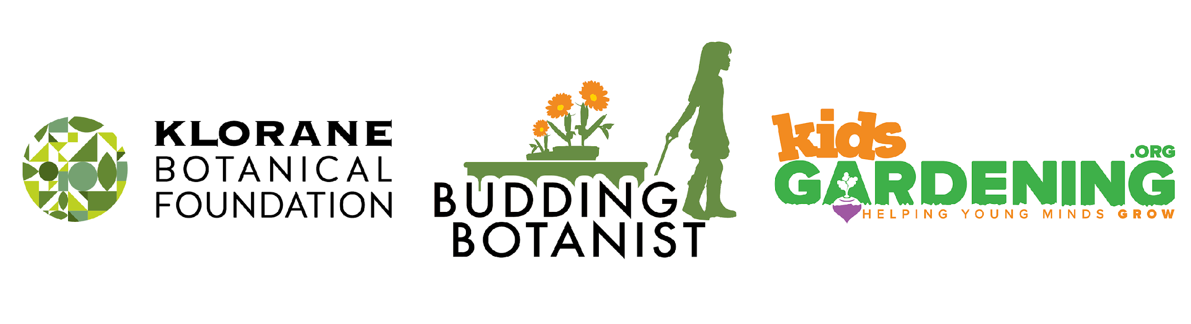
KidsGardening is proud to be partnering with the Klorane Botanical Foundation to offer the 2021 Budding Botanist Grant.
The Klorane Botanical Foundation is committed to supporting programs to teach respect for the environment and protect nature through the preservation of plant species and biodiversity. Designed to further their mission, The Budding Botanist Grant will help our youngest citizens learn about plants, explore their world and inspire them to take care of the life they discover in their local ecosystems.
Who is Eligible to Apply: Any public school, charter school or private school serving grades K through 12 in the United States that can demonstrate that at least 40% of their student population would qualify for free or reduced price meals is eligible to apply. Applicants must be planning a new or expanding an existing school garden program designed to teach students about environmental sustainability and the importance of biodiversity. Given the limitations posed by distance and hybrid learning options, applications that propose projects focused on the creation of virtual garden-based learning opportunities or take home gardening kits to better serve students engaged in remote learning are also encouraged and accepted. Previous Budding Botanist winners are not eligible.
Grant Award: In 2021, fifteen Budding Botanist Grants will be awarded. Each grant recipient will receive a check for $1000 to spend on materials to help bring garden-based learning opportunities to students. Schools will also receive a package of tools and educational materials valued at $200.
Grant Recipient Requirements: All funded programs must implement their proposed project by the end of the 2020-2021 school year, including the creation of a short video documenting their project progress. This video, along with information about the garden programs of grant recipients will be shared digitally and through social media. Schools must distribute and collect media releases forms for any students featured in videos or photos.
Grant recipients will also be required to complete an end of the year report, providing a minimum of 5-10 digital images of the garden program (with parental release forms for photos of youth as needed) by December of 2021 to document the impact of the program on your students and community.
Due Date: Applications must be submitted by October 30, 2020.
The following questions are included in the KidsGardening 2021 Budding Botanist application. We strongly advise saving the questions into a Word document and copying and pasting your answers into the application.

Contact Information

1. Primary Contact:

2. Primary Contact Title:

3. School/Organization:

4. Email Address:

5. Phone:

6. Garden Program Name:

7. Shipping Address (street address, no P.O boxes please):
Please provide one physical address. Award package will ship to this address.

8. City:

9. State:

10. Zip Code:

11. Daytime Phone Number:
Please list a phone number that corresponds with the shipping address.

12. Organization type:
Public School
Charter School
Other:

13. What percentage of direct participants are eligible for free/reduced cost lunch programs? (*must be greater than 40%. Applicants should be prepared to provide supporting documentation if requested.)

14. How many youth from each age group will participate directly in the garden program?
Elementary (Grades K-5)
Middle School/Junior High (Grades 6-8)
High School (Grades 9-12)

15. Is your garden program already established or are you just getting started?
New/Start-up Garden Program
Established Garden Program

16. How many hours per week on average will participating youth be involved in gardening activities?

17. How many months of the year will you be facilitating gardening programming?

18. If chosen as a winner for the 2021 Budding Botanist Grant Program, I agree to submit a short video documenting my project progress to KidsGardening and the Klorane Botanical Foundation.
Yes
No

19. If chosen as a winner for the 2021 Budding Botanist Grant Program, our school is willing to have our story shared digitally and in social media through images and video.
Yes
No

20. If chosen as a winner for the 2021 Budding Botanist Grant Program, I agree to complete a year-end report survey including a program summary and at least 10 photos from our garden program.
Yes
No

Program Overview

21. Provide a concise overview of your gardening efforts. List the educational goals of your program, describe the youth who will participate and how they will be engaged in the garden, and share innovative aspects of your program. Additionally, explain how you plan to implement your proposed project given the realities of Covid-19. Please consider how your project will be complete in such a way that it ensures the safety and continued health of all participants and how it can be adapted to variou learning models (in-person, hybrid, fully remote) should the need arise. (limit 1000 words)

22. Describe when and how frequently students will engage in garden programming. How does your garden program fit into your school’s curriculum? (limit 250 words)

23. How is your gardening program going to be used to promote environmental sustainability and biodiversity? (limit 500 words)

24. Will your students share what they are learning with the larger community? If so, please explain. (limit 500 words)

Leadership Team and Volunteers

25. List the individuals on your program’s leadership team and describe each leader’s experience in garden-based education and how they are involved in your program. Also, describe how/if your garden program recruits and utilizes volunteer help. (Limit 500 words)

Garden Plans

26. What type of garden resources are currently in use at your school:
in ground beds
raised beds
containers
indoor grow lights
no existing garden space on site
take home gardening kits
virtual gardening resources
other

27. If you have an existing garden, describe how you plan to expand your growing space if you receive this grant. If this will be your school’s first garden, describe your design plan. If you are requesting grant funds to create alternative garden-based programming (ex: virtual resources, take home gardening kits, etc.) please describe your strategy for delivering these hands-on experiences. (limit 250 words)

28. Describe the type of plants you will feature in your programming and how your choices relate to teaching students about environmental sustainability and/or biodiversity. (limit 250 words)

29. Budget. Please provide a detailed account of how you will spend the money if you are awarded a Budding Botanist Grant. If you will need additional funding, please describe how you plan to obtain it. (limit 250 words)

30. Please explain your school’s need for this funding and what impact receiving this grant could have on your students. (limit 250 words)

31. How do you plan to sustain your program in the future (e.g., ensure ongoing maintenance and leadership; build partnerships; find sources and/or funds for plant materials, services, tools, etc.)? If your program takes a break during summer months, what do you plan to do with your garden or garden programming? (limit 250 words)

Attachments

Supporting Photos and Documents
32. Please attach at least 2 photos to help us better understand your program, participants, and existing or potential garden site. If you have a map of your garden site or proposed garden site that includes location and dimensions, we encourage you to include this here.

33. Letter of Support (optional but highly encouraged)
Please attach a letter of support for your program written by someone other than the main contact. This letter can be written by an administrator, parent or community volunteer demonstrating their support of and appreciation for your program.

