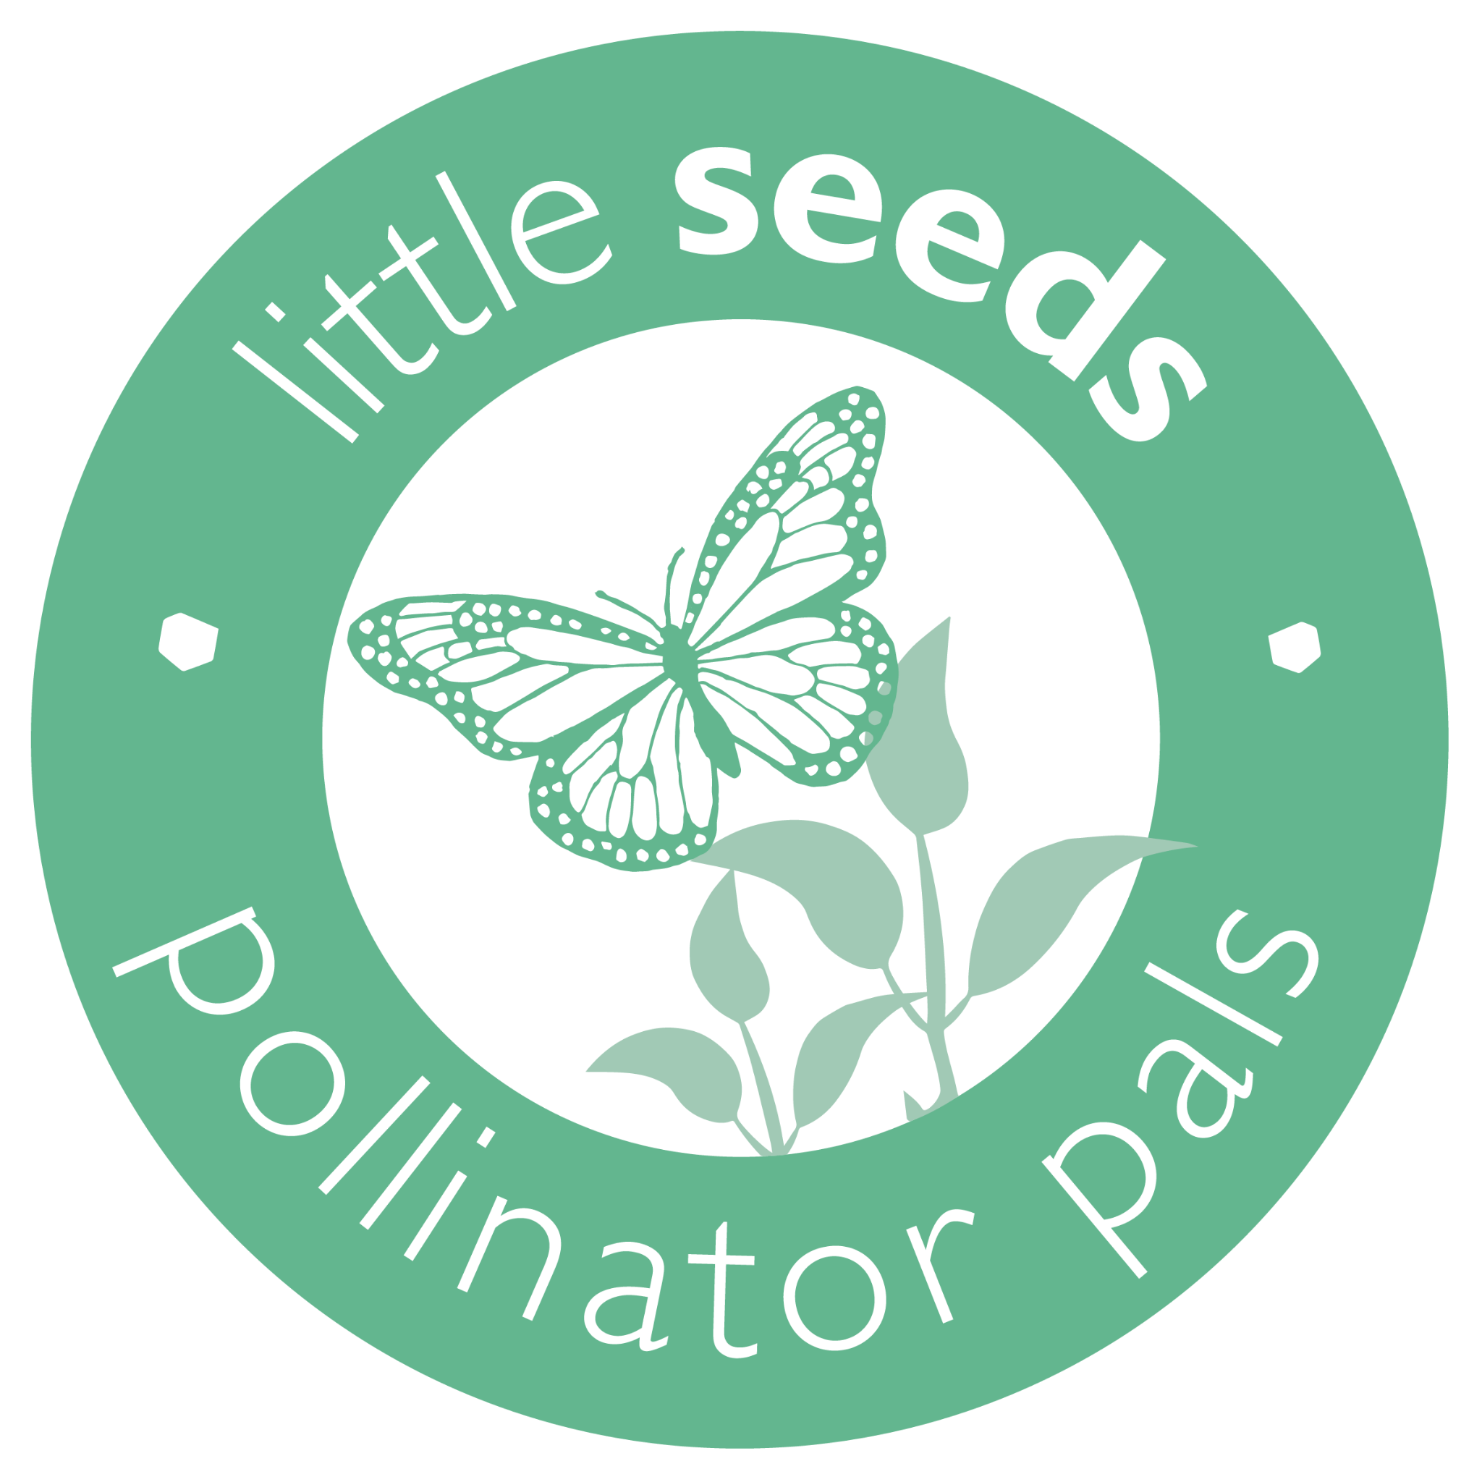
Little Seeds Pollinator Pals Grant Sample Application

KidsGardening is proud to be partnering with
Little Seeds to offer the 2021 Little Seeds Pollinator
Pals Grant.

The Little Seeds Pollinator Pals Grant presented by Little Seeds and KidGardening is designed to support youth garden programs interested in preserving and creating pollinator habitat to help rebuild declining pollinator populations. In 2021, eighteen programs will be awarded $500 each to support the development of new and expansion of existing pollinator gardens in communities across the United States.
Who is Eligible to Apply: Any nonprofit organization, public or private school, or youth program in the United States serving at least 15 youth between the ages of 0 and 14 is eligible to apply. Programs must be planning a new pollinator garden or expanding an existing one designed to teach youth about the importance of pollinators.
Grant Award: Eighteen programs will receive checks for $500 to spend on materials to establish or augment pollinator habitat.
Reporting Requirements: Grant awardees will be required to report on their pollinator garden’s progress by June 20, 2022. Winners will be provided with a link to an online survey to complete. The survey will include questions to determine the impact of the pollinator garden program on participating youth and community members and will request:
- A short narrative about the impact of the garden program.
- 5-10 digital images of your pollinator garden
- Signed parental release forms for any youth included in your images
If you do not feel that you will be able to comply with these reporting requirements, please do not apply. Recipients who do not complete these requirements will not be eligible to apply for future grant awards.
Due Date: Applications are due on Friday, July 30, 2021 by 11:59 pm PT.
Sample Application: The following questions are included in the 2021 Little Seeds Pollinator Pals application. We strongly advise saving the questions into a Word document and copying and pasting your answers into the application. Many browsers are set to timeout after 30 minutes of inactivity (or sometimes sooner) and so you may lose your work if it takes longer than your brower’s setting to complete or save your entry.
As a reminder, applications must be submitted online. The following link will take you to the application landing page: https://kidsgardeninggrants.limequery.org/162553?lang=en
1. Primary Contact First Name:

2. Primary Contact Last Name:
3. Primary Contact Title:
4. School/Organization Name:
5. Email Address:
6. Phone:
7. Garden Program Name:
8. Location Name (Location of the garden by the official name of school or facility to receive the award (e.g. "Washington Elementary School," "Fairview Botanical Garden"):
9. Shipping Address (no P.O. boxes please):
10. City:
11. State or Territory:
12. Zip Code
13. Daytime Phone Number:
14. Which of the following best describes your organization:
Public School
Private School
Charter School
Nonprofit Agency
Community Garden
Day Care/Child Care
Garden Club
Summer Camp
YMCA
Boys and Girls Club
Boy Scouts or Girl Scouts
Other:_________________

15. How many youth from each age group will participate directly in the garden program?
Ages 2-5 (Preschool to K)
Ages 6-8 (Grades 1-3)
Ages 9-11 (Grades 4-6)
Ages 12-14 (Grades 7-8)
16. Approximately what percentage of your direct participants are eligible for free/reduced cost lunch programs?
17. How many months of the year will you be using your pollinator garden space for educational activities?
18. If chosen as a winner for the 2021 Little Seeds Pollinator Pals Grant, will you agree to submit a year end report with a project summary, pictures, and parental release forms?
Yes
No
19. Do you have an established pollinator garden or are you just getting started?
New/Start-up Pollinator Garden
Established Pollinator Garden
20. Program Overview: Provide a concise overview of your garden program/project. List the educational goals of your program/project, describe the youth who will participate and specifically how they will be engaged in learning about pollinators. Please share any innovative aspects of your program. (Limit 500 words)
21. How is your program/project going to promote the preservation and creation of pollinator habitat within the larger community?
22. Is your program/project specifically designed to engage any traditionally under resourced populations? Select all that apply:
Youth of Color
Native American Youth
English Language Learners
Justice-involved Youth
Youth with Disabilities
Youth in Foster Care
Youth Experiencing Homelessness
Children of Migrant Workers
LBTGQ+ Youth
Children of Refugee Families
N/A
Other:_________________
23. If you selected any of the under resourced populations above, please describe how your pollinator garden and associated learning opportunities are specifically designed to engage these youth. (Limit 250 words)
24. Garden Description. Describe in detail the design or planned design of the pollinator garden that is established or that you intend to create. Describe the work that has been done to date to implement your plans. (Limit 250 words)
25. What is the approximate size of your existing garden or planned garden space in square feet?
26. Please provide a detailed account of how you will spend grant funding if you are awarded a Little Seeds Pollinator Pals grant. If you will need additional funding to achieve your plans, please describe how you plan to obtain it. (Limit 250 words)
27. Leadership & Support: List the individuals on your garden program’s leadership team. Describe each leader’s experience in gardening with kids and how they are involved in your garden program/project. Additionally, list community members, organizations, and businesses that actively support your pollinator garden and explain how they contribute to your garden efforts. (Limit 500 words)
28. Garden Sustainability & Maintenance: How do you plan to sustain your pollinator garden in the future (e.g., ensure ongoing maintenance and leadership; build partnerships; find sources and/or funds for plant materials, services, tools, etc.)? Please be as specific as possible. If your program takes a break during summer months, what do you plan to do with your garden? (Limit 250 words)
29. Supporting Photos and Documents: Please attach at least 2 photos to help us better understand your program, participants, and garden site. If you have a map of your garden site that includes dimensions we strongly encourage you to include that here. There is a 1024KB limit on each photo file. Photos should be uploaded here in .jpg, .pdf or .png format.
30. Optional Letter of Support: Please attach a one page letter of support for your program written by someone other than the main contact. This letter can be written by an administrator, parent or community volunteer demonstrating their support of and appreciation for your program. There is a 1024KB limit on each photo file. Photos should be uploaded here in .jpg, .pdf or .png format.

