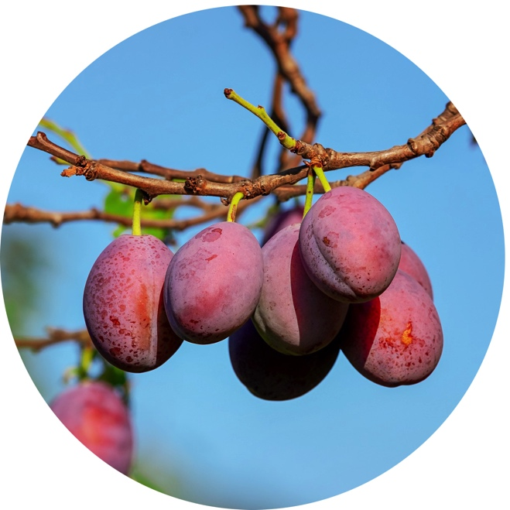
Exploring Food Forests

Overview: Another way to grow edible plants, a food forest strives to mimic the relationships found in natural forest ecosystems to sustainably grow fruit- and nut-bearing trees, shrubs, perennials, and annuals that provide a food source for humans and wildlife.

Grade Level/Range: 6th – 12 Grade

Objective:
Students will
- explore the relationships found in forest ecosystems
- investigate the concept of planting a food forest
- research appropriate plant materials and create a design for a food forest in their area

Time: 3+ hours

Materials:
- internet access
- graph paper and pencils

Background Information
A food forest is designed to replicate the interdependent relationships found in natural forest ecosystems to grow food-bearing plants — trees, shrubs, perennials, and annuals — to create a cohesive, relatively self-sustaining system. The plants in the food forest benefit each other, they benefit people by providing food, and they also create a welcoming space for wildlife.

In planning and planting a food forest, careful attention is paid to creating layers:
Canopy - Large fruit and nut trees create the canopy.
Understory - Smaller trees, such as dwarf fruit trees, create the understory.
Shrub - Next are shrubs of various sizes, such as blueberries and currants.
Herbaceous- The next layer consists of non-woody (herbaceous) perennials, e.g. rhubarb, asparagus, and many herbs.
Ground Cover - The soil surface can be considered a layer, populated with groundcovers such as creeping thyme.
Roots - The soil itself is a layer (called the rhizosphere) that is home to root vegetables.
Climbers - Finally, there’s a vertical layer, made up of climbing vines such as kiwis, that spans the other layers.

Some of the benefits of installing a food forest include:
They protect the soil. Because most of the plants are perennial, there’s little or no need to dig, rototill, or otherwise disturb the soil. This preserves the natural soil structure, its intricate ecosystem, and the remarkable array of life forms it sustains, including bacteria, fungi, insects, earthworms, and even small mammals. The deep roots of trees, shrubs, and perennials also help hold the soil in place, minimizing the erosion of precious topsoil.

They recycle nutrients. When plants shed their leaves, it creates a natural layer of mulch. This leaf litter feeds earthworms and soil microbes which, in turn, release the nutrients so they can be taken up again by the plants. Usually little to no additional fertilizer is needed in a food forest, except perhaps some compost around heavily harvested plants.

They conserve water. Perennial plants generally have deeper root systems than small, annual plants, so they can reach further into the soil for the water they need. If watering is necessary, an occasional slow, deep watering is usually adequate — rather than the almost-daily watering that many annual crops demand. Trees and tall shrubs provide shade for lower-growing plants, reducing water stress during the mid-day heat. Ground covers and fallen leaves conserve soil moisture.

They offer an abundant harvest over a long season. Spring asparagus, summer berries, fall apples, root crops through early winter and even into the following spring — depending on your climate, a food forest can have something to offer nearly year-round.

They require less work!

Find additional details in the KidsGardening article Food Forests: Growing Edibles from Soil to Treetops: https://kidsgardening.org/garden-how-to-food-forest/

Laying the Groundwork
Have students read the article “5 Things You Might Not Know About Forests – But Should” by the World Economic Forum.

As a class, list the 5 benefits of forests being promoted by the FAO (The Food and Agriculture Organization of the United Nations). You may want to download a copy of the FAO’s infographic about the benefits as a resource.

Either as an individual assignment or working in teams, have students choose one of the listed benefits and find statistical evidence supporting the benefit they select. Links and supporting data can be found in the article from the World Economic Forum, or for more advanced students, you may want to suggest they check out the FAO publication The State of the World’s Forests 2020.

Ask students to find a way to creatively compile their findings (a poster, a slide presentation, a video) and then share back with the class. You may want to consider using the following questions to spark discussion:
- How important are forests to our planet?

- What is the current state of our forest ecosystems? Why should we care?

- What can we do to help protect and conserve our forest ecosystems? What are some of the factors that make these solutions complicated?

Exploration
1. Food forests are being explored as alternatives to traditional food gardens. They draw on the relationships found in natural forests and try to mimic those in a controlled setting.

You may want to use the following videos showing slightly different perspectives on a food forest to help your students visual what a food forest can look like:

- The Forested Garden: What is a Food Forest? By Geoff Lawton
https://www.youtube.com/watch?v=hCJfSYZqZ0Y

- Lawn to Food Forest from The Gardening Channel with James Prigioni
https://www.youtube.com/watch?v=PaozyVnrOsM

2. Explain to students that successful food forests are going to look very different all over the world because they center on working in harmony with your local environment and available site conditions. You can choose to focus solely on trees and plants that are native to an area or expand to include both native and non-native plants. What is the same about all food forests is that they incorporate each of the different forest layers. Share the layers as listed in the Background Section (canopy, understory, shrub, herbaceous, ground cover, roots, and climbers). Explain each layer and share an example of each (you can find examples in the KidsGardening article Food Forests: Growing Edibles from Soil to Treetops: https://kidsgardening.org/garden-how-to-food-forest/. Ith Discuss how the layers help the plants and animals in the ecosystem work together to benefit each other and cycle natural resources.

3. Individually or working in teams, assign students the task of planning and designing a food forest for your school, a community green space, or their home. For this assignment ask them to:
- Select at least one plant representing each of the layers.
- Choose plants that can grow under your climate conditions.

To help them with this task, you may want to check with your local extension office and/or native plant societies to see what resources they have available regarding recommended plants for your area. Use the North American Native Plant Society’s webpage to find your local native plant society: http://nanps.org/native-plant-societies/. Use the USDA’s page to find your state’s land grant university and local extension offices: https://nifa.usda.gov/land-grant-colleges-and-universities-partner-website-directory.

The following resources from the Permaculture Apprentice may also be helpful:
Creating a Food Forest – Step by Step Guide
https://permacultureapprentice.com/creating-a-food-forest-step-by-step-guide/

How to Choose the Right Plants for Your Food Forest Guilds:
https://permacultureapprentice.com/pfaf/

4. To complete their project, ask them to create a to-scale design on graph paper and also include a full description of the selected plant materials in a separate document.

5. Conclude the activity by having them share their designs through formal presentations. Ask students to reflect on what they learned and any favorite plants they discovered. Ask them to share their thoughts on the value and relevance of food forests in your community.

6. If you want to take the activity to further, ask them to gather price estimates for their design. Beyond the environmental impact of a food forest, discuss the financial viability of installing a food forest at individual homes and/or community-owned properties.

Making Connections
Permaculture expert Geoff Lawton shared the following quote: “You can solve all the world’s problems in a garden.” Lead students in a discussion or debate in favor or opposed to that statement.

Dig deeper into some examples of food forest installations. Here are two articles about a food forest in Atlanta that you could use for discussion:

- A Food Forest Grows in Atlanta:
https://www.usda.gov/media/blog/2018/05/04/food-forest-grows-atlanta

- This southern city is fighting food deserts with a forest of free produce
https://www.cnn.com/2019/05/24/us/atlanta-food-forest-fighting-food-desert/index.html

Branching Out

Focus on pollinators. Pollinators play a very important role in the lifecycle of many edible fruits (including those in food forests). Introduce topics like symbiotic relationships, habitat, and environmental protection while investigating these little helpers. Polliantor.org is a great place to find resources including regional pollinator-friendly planting guides.

Enjoy seasonal fruits. Eating fruits in season offers opportunities for students to better understand the lifecycles of fruit trees and to explore our food system from a global perspective. Many states offer some kind of Harvest of the Month Program. For example, the Network for a Healthy California offers a comprehensive program called Harvest of the Month that provides educator, family, and community newsletters about different fruits and vegetables by season, along with menu slicks that can be used in cafeteria settings. Use the National Farm to School Network’s map to find your state’s farm to school resources.

Explore fruity art. Fruit is a common subject for art. Paul Cézanne is a French post-impressionist known for still-life paintings and he created over 200 pieces including his Still Life with Apples and Pears that can be found at The Metropolitan Museum of Art. Using Cézanne’s or other artists’ work as inspiration, have students study fruit with an artist’s eye and create their own still life paintings and drawings.

Learn Preservation Techniques. Before global transport of fruit became affordable, most people relied on preservation techniques such as canning or drying to save fresh harvest like apples, pears, and peaches for out-of-season enjoyment. In addition, preservation is important because many plants bear fruit in such large quantities that they can not be consumed all at one time. Explore the science behind different preservation techniques with your students and try your hand at saving some harvest. For more information check out the article on Preserving the Harvest.

Link to Standards
This lesson can be used to connect to the following Next Generation Science Standards Performance Expectations:

MS-LS2-1. Analyze and interpret data to provide evidence for the effects of resource availability on organisms and populations of organisms in an ecosystem.

MS-LS2-5. Evaluate competing design solutions for maintaining biodiversity and ecosystem services.

HS-LS2-1. Use mathematical and/or computational representations to support explanations of factors that affect carrying capacity of ecosystems at different scales

HS-LS2-7. Design, evaluate, and refine a solution for reducing the impacts of human activities on the environment and biodiversity.

